**ECOMMERCE**

**Schema:**

**Creation of Database:**

Create database ecomm;

Use ecomm;

**Customer Table:**

create table customers(

customer_id int primary key,

name varchar(20) not null,

email varchar(20) not null,

address varchar(50) not null,

password varchar(30) not null

);

**Products Table:**

create table products(

product_id int primary key,

name varchar(30) not null,

price decimal(10,3) not null,

description varchar(30) not null,

stockQuantity int not null

);

**Cart Table;**

CREATE TABLE cart (

cart_id INT PRIMARY KEY,

customer_id INT,

product_id INT,

quantity INT,

CONSTRAINT cart_fk_cus_id

FOREIGN KEY (customer_id)

REFERENCES customers(customer_id),

CONSTRAINT cart_fk_prod_id

FOREIGN KEY (product_id)

REFERENCES products(product_id)

);

**Orders Table:**

create table orders(

order_id int primary key,

customer_id int ,

order_date date not null,

total_price decimal(10,2) not null,

shipping_address varchar(30) not null,

constraint orders_fk_cus_id

foreign key(customer_id)

references customers(customer_id)

);

**Order_items_table:**

create table order_items(

order_item_id int primary key,

order_id int,

product_id int,

quantity int not null,

constraint order_items_fk_ord_id

foreign key(order_id)

references orders(order_id),

constraint order_items_fk_prod_id

foreign key(product_id)

references products(product_id)

);

**Table Inputs:**

**Customer Table:**

Insert into customers

(customer_id, name, email, address, password)

values

(1, 'John Doe', 'johndoe@example.com', '123 Main St, City','JohnDoe123'),

(2, 'Jane Smith', 'janesmith@example.com', '456 Elm St, Town', 'JaneSmith123'),

(3, 'Robert Johnson', 'robert@example.com', '789 Oak St,Village', 'RobertJohnson123'),

(4, 'Sarah Brown', 'sarah@example.com', '101 Pine St, Suburb', 'SarahBrown123'),

(5, 'David Lee', 'david@example.com', '234 Cedar St, District', 'DavidLee123'),

(6, 'Laura Hall', 'laura@example.com', '567 Birch St, County', 'LauraHall123'),

(7, 'Michael Davis', 'michael@example.com', '890 Maple St, State', 'MichaelDavis123'),

(8, 'Emma Wilson', 'emma@example.com', '321 Redwood St, Country', 'EmmaWilson123'),

(9, 'William Taylor', 'william@example.com', '432 Spruce St, Province', 'WilliamTaylor123'),

(10, 'Olivia Adams', 'olivia@example.com', '765 Fir St, Territory', 'OliviaAdams123');

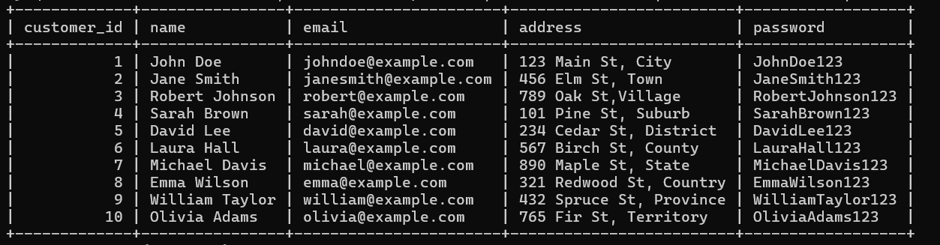

**Products table:**

insert into products (product_id, name, description, price, stockQuantity)

values

(1, 'Laptop', 'High-performance laptop', 800.00, 10),

(2, 'Smartphone', 'Latest smartphone', 600.00, 15),

(3, 'Tablet', 'Portable tablet', 300.00, 20),

(4, 'Headphones', 'Noise-canceling', 150.00, 30),

(5, 'TV', '4K Smart TV', 900.00, 5),

(6, 'Coffee Maker', 'Automatic coffee maker', 50.00, 25),

(7, 'Refrigerator', 'Energy-efficient', 700.00, 10),

(8, 'Microwave Oven', 'Countertop microwave', 80.00, 15),

(9, 'Blender', 'High-speed blender', 70.00, 20),

(10, 'Vacuum Cleaner', 'Bagless vacuum cleaner', 120.00, 10);

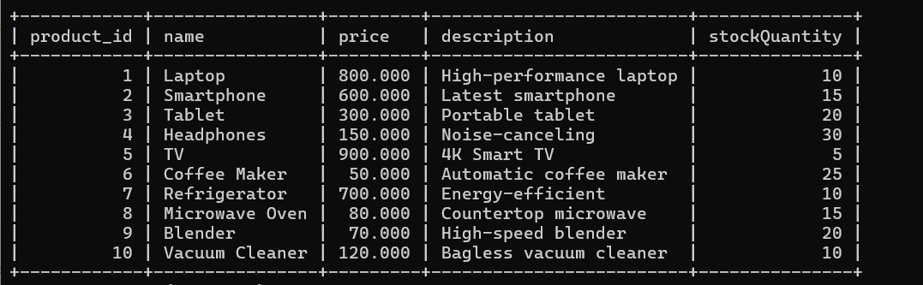

**Cart table:**

insert into cart (cart_id, customer_id, product_id, quantity)

values

(1, 1, 1, 2),

(2, 1, 3, 1),

(3, 2, 2, 3),

(4, 3, 4, 4),

(5, 3, 5, 2),

(6, 4, 6, 1),

(7, 5, 1, 1),

(8, 6, 10, 2),

(9, 6, 9, 3),

(10, 7, 7, 2);

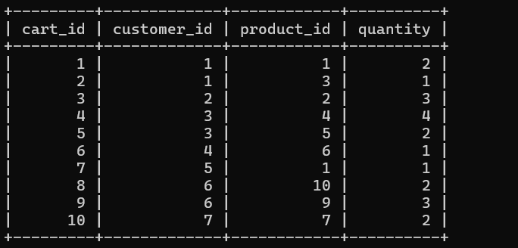

**Orders table:**

insert into orders (order_id, customer_id, order_date, total_price, shipping_address)

values

(1, 1, '2023-01-05', 1200.00, '123 Main St, City'),

(2, 2, '2023-02-10', 900.00, '456 Elm St, Town'),

(3, 3, '2023-03-15', 300.00, '789 Oak St, Village'),

(4, 4, '2023-04-20', 150.00, '101 Pine St, Suburb'),

(5, 5, '2023-05-25', 1800.00, '234 Cedar St, District'),

(6, 6, '2023-06-30', 400.00, '567 Birch St, County'),

(7, 7, '2023-07-05', 700.00, '890 Maple St, State'),

(8, 8, '2023-08-10', 160.00, '321 Redwood St, Country'),

(9, 9, '2023-09-15', 140.00, '432 Spruce St, Province'),

(10, 10, '2023-10-20', 1400.00, '765 Fir St, Territory');

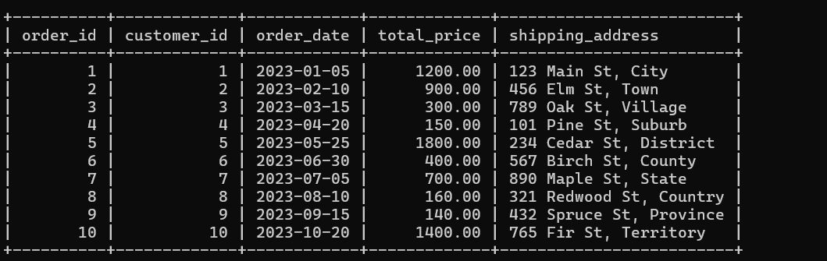

**Order_items:**

insert into order_items (order_item_id, order_id, product_id,

quantity)

values

(1, 1, 1, 2),

(2, 1, 3, 1),

(3, 2, 2, 3),

(4, 3, 5, 2),

(5, 4, 4, 4),

(6, 4, 6, 1),

(7, 5, 1, 1),

(8, 5, 2, 2),

(9, 6, 10, 2),

(10, 6, 9, 3);

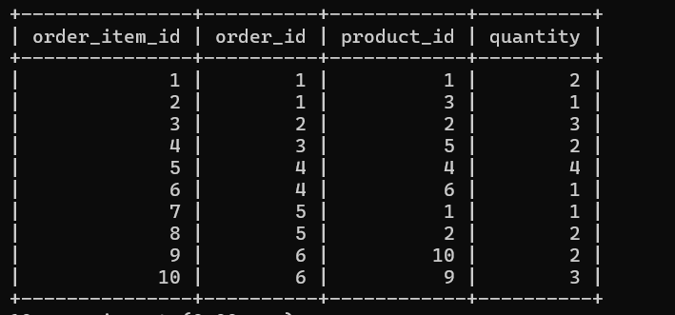

**Task Query:**

1. Update refrigerator product price to 800.

update products

set price=800

where name="refrigerator";

2. Remove all cart items for a specific customer.

delete from cart

where customer_id=

(select customer_id from customers

where name="Michael Davis" );

3. Retrieve Products Priced Below $100.

select product_id,name,price,description,stockQuantity

from products

where price < 100;

4. Find Products with Stock Quantity Greater Than 5.

select product_id,name,stockQuantity

from products

where stockQuantity > 5;

5. Retrieve Orders with Total Amount Between $500 and $1000.

select order_id,customer_id,order_date,total_price

from orders

where total_price between 500 and 1000;

6. Find Products which name end with letter ‘r’.

select name

from products

where name like '%r';

7. Retrieve Cart Items for Customer 5.

select cart_id,customer_id,product_id,quantity

from cart

where customer_id = 5;

8. Find Customers Who Placed Orders in 2023.

select o.customer_id ,c.name,o.order_date

from orders o

join customers c

on o.customer_id=c.customer_id

where year(order_date)='2023'

9. Determine the Minimum Stock Quantity for Each Product Category.

select category as product_category ,min(stockQuantity)

from products

group by category;

10. Calculate the Total Amount Spent by Each Customer.

select o.customer_id,c.name,ifnull(o.total_price,0) as total_amount

from orders o

join customers c

on o.customer_id=c.customer_id;

11. Find the Average Order Amount for Each Customer.

select customer_id,avg(total_price) as average_amount

from orders

group by customer_id;

12. Count the Number of Orders Placed by Each Customer.

select customer_id,count(customer_id) as no_of_orders

from orders

group by customer_id;

13. Find the Maximum Order Amount for Each Customer.

select customer_id,max(total_price) as max_order_amount

from orders

group by customer_id;

14. Get Customers Who Placed Orders Totaling Over $1000

select customer_id,sum(total_price) as Total_amount_spent

from orders

group by customer_id

having Total_amount_spent > 1000;

15. Subquery to Find Products Not in the Cart.

select product_id,name

from products

where product_id not in (

select product_id from cart);

16. Subquery to Find Customers Who Haven't Placed Orders.

select customer_id, name

from customers

where customer_id not in (

select customer_id from orders)

17. Subquery to Calculate the Percentage of Total Revenue for a Product.

select i.product_id,

sum(i.quantity * p.price) as product_revenue,

(sum(i.quantity * p.price) /

(select sum(i2.quantity * p2.price)

from order_items i2

join products p2 on i2.product_id = p2.product_id)) * 100 as revenue_percentage

from order_items i

join products p on i.product_id = p.product_id

group by i.product_id;

18. Subquery to Find Products with Low Stock.

select product_id,name ,stockQuantity

from products

where product_id in

( select product_id from products

where stockQuantity < 15)

19. Subquery to Find Customers Who Placed High-Value Orders

select customer_id, name

from customers

where customer_id in (

select customer_id

from orders

where total_price = (

select max(total_price)

from orders

)

);